2. WATER LEVEL CONTROL SYSTEM

AIM:
To design a ladder logic program to maintain the water level in a tank.

APPARATUS REQUIRED:

1. VPLCT - 01 [PLC Trainer kit].
2. Water level indicator [Float switches - 2].
3. PC.
4. RS - 232 cable.
5. Patch Chords.
PROCEDURE:
1. Load the Versapro Software to the PC.
2. Open the Versapro Software.
3. Switch ON the PLC Trainer and water level system.
4. Connect PLC and water level System kit.
5. Open the New folder and draw the ladder logic program.
6. Connect the PLC to PC.
7. Select the correct hardware Configuration [Sl. No].
8. Store the Program to PLC.
9. Run the Program.
10. Verify the performance of the water level System.
PROBLEM STATEMENT:
Water Level controller is used to Fill/drain the tank, which is depends upon high/low level in tank water. If the tank is in low level the solenoid valve will open & motor starts - ON Position if the tank is in high level, the solenoid valve will be close & motor stop - OFF position.

BLOCK DIAGRAM:

PROCESS DIAGRAM:

WIRING DIAGRAM:

LADDER DIAGRAM:

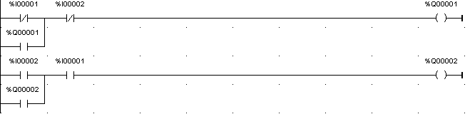

RESULT:
Thus the ladder logic program to maintain the water level in a tank has been designed and tested using the water level kit.

